**SRS REPORT**

**TITLE: CANTEEN AUTOMATION SYSTEM**

**SUBMITTED BY:**

MANIKANDAN C

ANJANA BK

**ABSTRACT:**

People don't have much time to spend in the canteen just sitting there and waiting for the food. Sometimes they will not get food because of insufficient food. There will be queues and consists of a manual workload that involves the paperwork of the billing system and maintaining the files too. Manual systems usually create problems during peak hours. In the proposed system there is no need for paperwork. This canteen automation system enables the end users to register online, read and select the food from the e-menu card and order food online by just selecting the food that the user want to have. Canteen automation reduces waiting times. It provides cancellation of order with a time limit and option to print the orders in admin side. There is also option for hiding the dish if it is not available and display box option from the admin side to give daily information.

**LITERATURE SURVEY**

We looked at various research papers to understand all the previous work done on the project we undertook.

[1] The ordering system paper, tackled the similar project but it was not able to finish and confirm the order, as they lacked the payment.

[2] Menu automation paper, only was able to generate a real time menu of the items available but unable to place order on behalf of the customer

[3] The project deals with the development of the online platform for the customers and the owners of the restaurant.

[4] Android based Ordering system – They implemented the project but with the drawback of payment only through cash on delivery.

[5] Online Menu Ordering – This paper referred to a technique which was implemented by the user to be using a portal which was based on an outdated framework.

<https://www.researchgate.net/publication/347162016_Canteen_Automation_System_with_Payment_Gateway_-_A_Survey>

<https://www.academia.edu/44602509/Canteen_Automation_System_with_Payment_Gateway_A_Survey>

**HIGH LEVEL ARCHITECTURE**

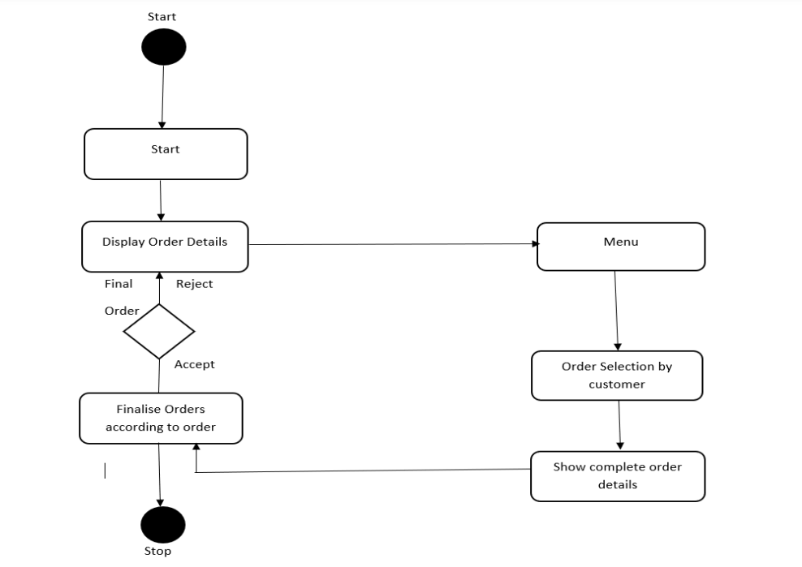

**Hardware Requirements**

* Processor: Pentium 4 or higher
* RAM: 512 MB or more
* Memory Space 80 GB or higher.

**Software Requirements**

* PHP version 5.4.3
* My SQL Database 5.5.24
* Apache Web Server 2.2.22
* Browser
* JavaScript

**Non-Functional Requirements**

Non-functional requirements (NFRs) describe the characteristics and attributes of a software system that are not related to the specific functions it performs. In the case of the Canteen Automation System, the non-functional requirements are as follows:

**1.Performance:** Performance is an essential aspect of any software system. The performance of the Canteen Automation System should be satisfactory to ensure that users are not waiting for long periods to access the system's functionality. The system should respond to user requests quickly, with minimal delay. The system should also be able to handle large volumes of traffic during peak hours without any significant degradation in performance.

**2.Security:** Security is a critical aspect of any software system, particularly when handling sensitive data such as payment information and user credentials. The system should be secure, with appropriate measures to protect sensitive data. The system should include secure protocols for data transmission, password policies, and access control mechanisms.

**3.Reliability:** The system should be reliable, with minimal downtime and errors. The system should be designed to handle potential failures in hardware or software, and mechanisms should be put in place to recover from such failures without affecting the overall system's availability.

**4.Usability**: Usability is an essential factor in ensuring user satisfaction. The system should be easy to use, with an intuitive user interface that makes it easy for users to navigate the system's functionality. The system should also provide user feedback, such as confirmation messages and progress bars, to keep users informed of the system's progress.

**5.Compatibility:** The system should be compatible with various web browsers and operating systems. The system should be tested on different browsers and operating systems to ensure compatibility.

**Conclusion**

The Canteen Automation System is a useful tool for managing canteen operations in educational institutions, corporate environments, and healthcare facilities. It allows customers to order and pay for food quickly and efficiently, reducing waiting times and promoting cashless transactions. The system also helps canteen managers track inventory levels, generate reports on food usage, and make informed decisions about inventory management. Overall, the Canteen Automation System can significantly improve the efficiency and accuracy of canteen operations.